Magnetic Toy
We specialized in the production and sale of Magnetic Toy, can be customized according to various Magnetic Toy, if you need to know more Magnetic Toy relations information, please contact us.
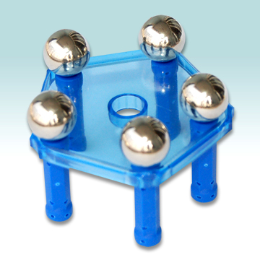

Permanent Magnet , Neodymium Magnet , Rubber Magnet , Alnico Magnet , Ferrite Magnet , NdFeB Magnets , Fecrco Magnet , Smco Magnet , Sintered AlNiCo , Sintered SmCo , Femite Magnet , Magnetic Olive , Sintered Ferrite , Magnetic Materials , Magnet Lifter , Magnetic Toy , Electromagnetic

